**User Manual**

* We will see how to test a Simple Calculator using Selenium

1. Folders

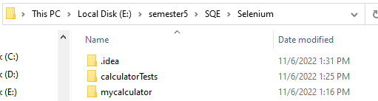

1. Files inside the Folder

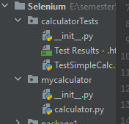

1. Code that will be Tested

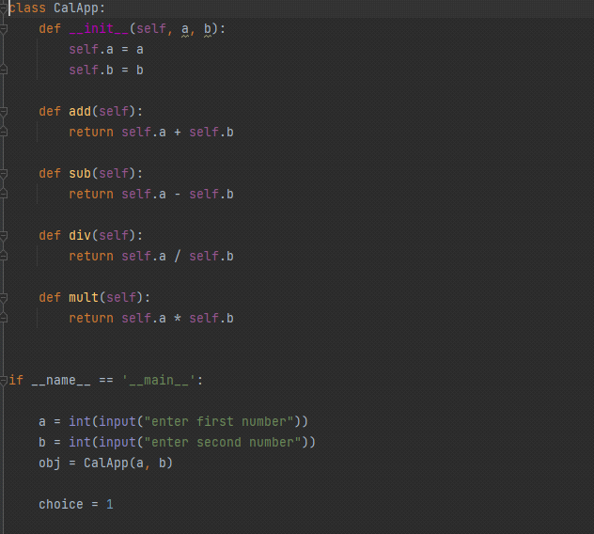

1. Using the Unit Test Library we will write all the test cases and give the expected output

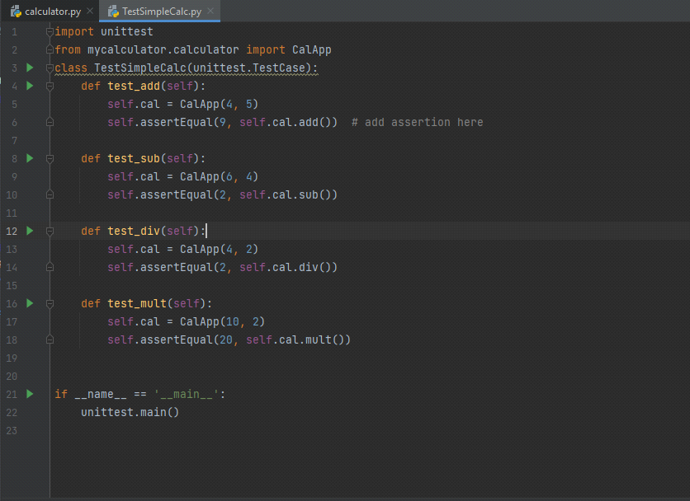

1. Output of the Test cases

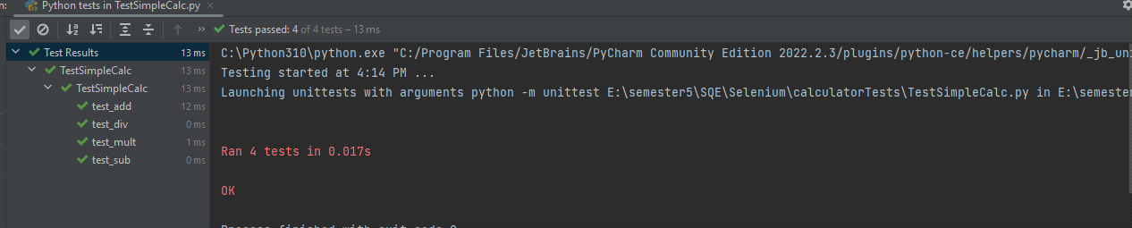

1. Test Report

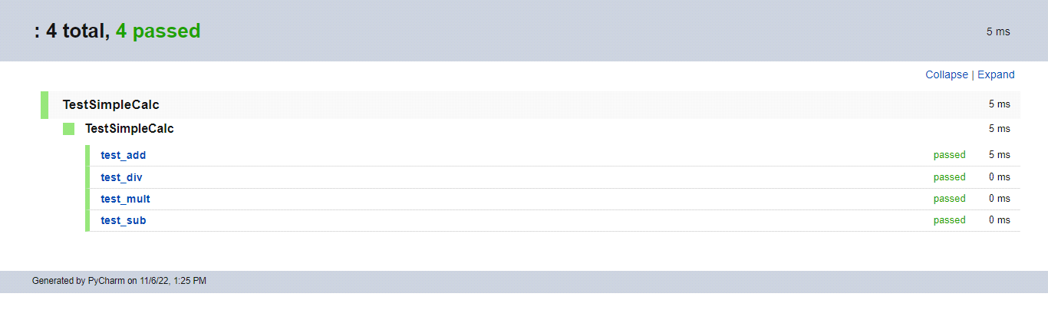

* All 4 functions add, subtract, divide, multiply were tested based on unit testing.